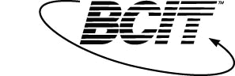
Object Oriented Analysis and Design

Week 04 – Lab (5 p)

Date:
Name:

Please complete the following Steps:

- In the context of the vehicle reservation system described last week, please read and understand the class responsibilities detailed in the table included. Usually the class responsibilities start with either “Manages” or “Knows”.

- Construct a UML class diagram showing the business classes and their relationships, including multiplicities. Name the significant relationships, starting with a verb.

- Explain where and why do we need to use an association class relationship.

Submit a word document containing the diagram and the answer to subject 3, as well as the model to D2L, Dropbox, LabWeek4.

Marking Guide for the Exercise

Category | Maximum | Mark
Classes | 4
Relationships | 3
Multiplicities | 1
The association class relationship | 2
Total | 10

